

Autonomous Last-Mile Delivery — Sector Report
Drones, Sidewalk Robots & Autonomous Vehicles: Market, Deal Activity, and Strategic Outlook for Walmart Corporate Development
Author: CorpDev.AI Analyst
Date: August 26, 2026

Table of Contents
Autonomous Last-Mile Delivery — Sector Report 3
Executive Summary 3
1. Market Overview & Size 3
Trajectory to 2030 and Global Benchmarks 4
2. Growth Drivers 5
Unit Economics and Willingness to Pay 6
3. Technology Segments 7
3a. Drone Delivery Operators 7
3b. Drone Hardware & UTM Platforms 7
3c. Sidewalk Delivery Robots 8
3d. Autonomous Last-Mile Vehicles 8
4. Recent M&A and Funding Activity 8
5. Key Risks & Watch Items 10
6. Outlook for Strategic Acquirers 10
Catalyst Timeline 11
Indicative Target Screen 12
Analyst's Notes 12

Autonomous Last-Mile Delivery — Sector Report

Executive Summary
Autonomous last-mile delivery has crossed from pilot theater into early commercial scale, and 2026 is the sector's breakout year: Walmart passed 1 million cumulative drone deliveries — 40% of them in FY27 Q1 alone [13] — Zipline's valuation doubled to $7.6B [48], and disclosed sector funding in the first eight months of 2026 (~$1.3B) exceeds full-year 2024 and 2025 combined (Section 4). Yet no scaled operator has been acquired outright, and the FAA's Part 108 BVLOS rule — the sector's single largest repricing catalyst — remains months from finalization [45].
1M+  WALMART CUMULATIVE DRONE DELIVERIES (MAY 2026) [13] | $7.6B  ZIPLINE VALUATION, JAN 2026 [48] | ~$1.3B  2026 YTD DISCLOSED SECTOR FUNDING (SECTION 4) | $1.50-3  SIDEWALK ROBOT COST/DELIVERY VS. $8-12 HUMAN COURIER [166, 174]

Key judgments:
1. The economics now work — but only on constrained, dense routes. Sidewalk robots already deliver at $1.50-3.00 per trip versus a fully loaded human courier cost of $8-12 [166, 174]; drones are economic for small, urgent orders at network density — not as general delivery replacement. Utilization, not technology, is the binding constraint: it is what killed DroneUp at ~$30/delivery [28] and what makes marginal independent assets accretive inside Walmart's 4,600-store network [29].
2. Drone control positions are repricing fast; ground assets remain accessible. Zipline is at $7.6B and Wing is captive to Alphabet [48]; by contrast, scaled sidewalk fleets (Starship, Coco) trade at venture-scale marks, the enabling hardware/UTM layer is modestly valued, and Gatik — already integrated into Walmart's middle-mile — just reset its ownership base with QIA/Koch capital [73, 82, 128].
3. Part 108 finalization is the clock. The final BVLOS rule entered OIRA review in July 2026 [45]; publication would standardize what today requires bespoke waivers and likely trigger a step-change in drone-operator and UTM valuations. Positions taken before finalization capture the repricing.
4. Competitors are assembling multi-modal networks now. Amazon acquired RIVR and is scaling Prime Air toward ~500 locales [54, 156]; Uber holds stakes across Zipline, Flytrex, Nuro, and Avride [105]; DoorDash backed Also and built its own robot [143, 145]. The current partnership-based equilibrium is hardening into closed networks.
Failed to fetch picture

1. Market Overview & Size
Autonomous last-mile delivery has moved from pilot theater to early commercial scale. The sector spans three delivery modalities — aerial drones, sidewalk robots, and autonomous road vehicles — plus an enabling layer of drone hardware and uncrewed traffic management (UTM) platforms. Published market sizings vary widely by definitional scope, and the leading segment estimates overlap; they should be read as indicative, not additive.
~$1.9B  DRONE DELIVERY MARKET, 2025 [1] | ~$1.6B  AUTONOMOUS GROUND LAST-MILE, 2025 [3] | ~$1.1B  SIDEWALK DELIVERY ROBOTS, 2025 [2] | 20-25%  SEGMENT CAGRS, 2025-2031 [1, 2, 3]

Best available estimates place drone delivery (hardware, autonomy software, docking infrastructure, and integration services) at approximately $1.9B in 2025, growing at a 21.6% CAGR [1]; sidewalk/ground delivery robots at approximately $1.1B, growing ~19.7% [2]; and the broader autonomous ground last-mile vehicle segment at approximately $1.6B, growing ~24.8% (derived from a $1.96B total autonomous last-mile market with an ~82% ground-vehicle share) [3]. The drone hardware & UTM layer lacks a cleanly published standalone size; we estimate it at roughly $0.6B, treating enabling hardware, docking, and airspace software as approximately one-third of the drone delivery market's defined scope [1] (see Analyst's Notes). McKinsey and Deloitte both identify autonomous ground vehicles, drones, and delivery droids as the defining last-mile technologies, with Deloitte reporting that 80% of surveyed companies were investing or planning to invest in them [5, 6].
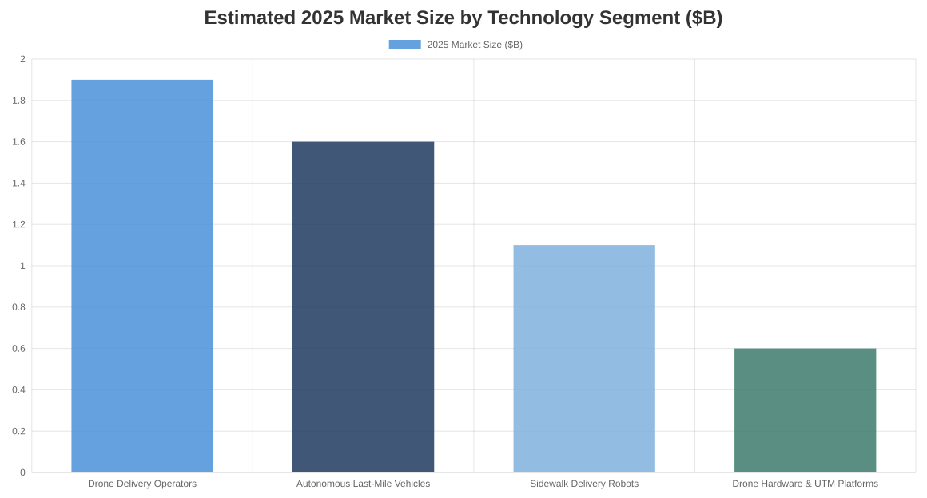
💭 Market Sizing Caveat
Segment estimates come from commercial market-research publishers with differing scopes and are partially overlapping (sidewalk robots are a subset of ground vehicles; the hardware/UTM figure is analyst-derived). Treat the ~$4-5B combined figure as directional; service-revenue definitions would yield materially higher totals [1, 2, 3].

Trajectory to 2030 and Global Benchmarks
The sector's growth story is steep but front-loaded in the drone segment. Grand View Research projects the total autonomous last-mile delivery market growing from $1.96B (2025) to $5.93B by 2030, a 24.8% CAGR [3]. Within that, drone delivery is expected to nearly triple its share — from roughly $2.9B in 2025 to $8.4B by 2030 on broader scoping that includes hardware and services [179] — while sidewalk delivery robots grow to roughly $2.8B [180]. Applying the current ~82% ground-modality share to the 2030 total implies an autonomous ground last-mile segment of roughly $4.9B (derivation in Analyst's Notes) [3].
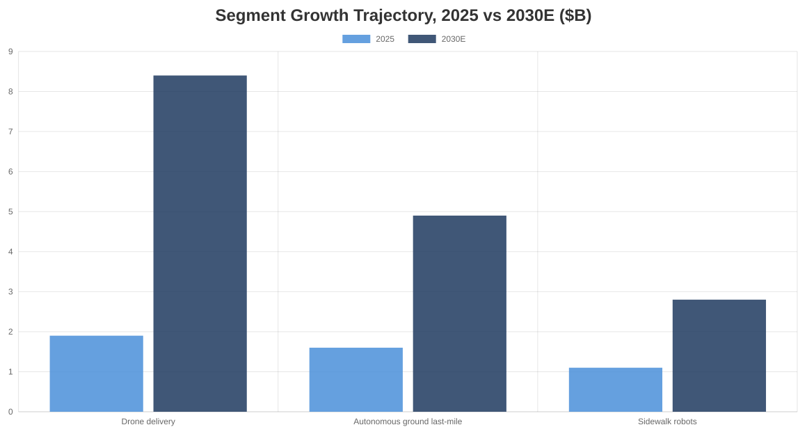
China is the operating benchmark, not the market forecast. Meituan has completed 900,000+ cumulative drone orders across 500+ route sites, with per-site daily capacity scaling from ~10 to ~400 deliveries as route density matured [210, 211] — yet drone volume still represents roughly 0.01% of Meituan's total order flow, a sober reminder of how long the tail of scaling is even in a permissive regulatory environment [210]. JD.com operates 3,200+ autonomous delivery units and is deploying 200-kg-payload drones for rural logistics [212], and Chinese forecasts anticipate the national autonomous delivery fleet growing from ~47,000 vehicles today to 1.5M by 2030 [216]. The lesson for U.S. strategics: the technology scales operationally where regulation permits, but autonomous share of total delivery volume remains small for years even at the frontier — network economics, not novelty, determine the ramp.

2. Growth Drivers
Fulfillment-from-store economics. Walmart's ~4,605 U.S. stores — substantially all offering same-day pickup and delivery — function as a distributed forward-inventory network, the structural precondition for autonomous last-mile economics [29]. U.S. e-commerce reached ~$79.3B in FY25 [29], store-fulfilled delivery grew ~50% in FY26 and ~45% in FY27 Q1, and expedited sub-three-hour deliveries now represent ~36% of store-fulfilled orders [35, 36]. Net delivery cost per order fell 20-40% across FY25 quarters on ~20% better batch density [31, 33, 34]. Autonomy is the next cost-curve lever: it targets the driver — the largest remaining variable cost per drop.
Labor cost pressure defines the target economics. DroneUp's experience is the sector's cautionary benchmark: ~$30 cost per drone delivery against a sub-$7 viability threshold, which drove Walmart to end that partnership at end-2024 and consolidate around operators with stronger automation and utilization [24, 28]. Every credible player's roadmap is a march from labor-intensive pilots toward high-utilization, low-touch networks.
FAA BVLOS (Part 108) rule progress. The FAA published its proposed beyond-visual-line-of-sight rule in August 2025 [38]; after two comment periods (closing October 2025 and February 2026), the draft final rule reportedly entered OIRA review in July 2026 but is not yet final as of August 2026 [39, 42, 45]. Current operations run on Part 107 waivers, Section 44807 exemptions, and Part 135 certifications — workable but bespoke. Finalization would replace operator-specific approvals with standardized performance requirements, materially lowering the cost and time to scale drone networks.
Walmart's own drone expansion is the sector's largest demand catalyst. Walmart crossed 1 million cumulative drone deliveries in May 2026 — 40% of them in FY27 Q1 alone — at a 23-minute average delivery time, from ~66-70 stores [13, 14]. Wing plans to reach 270+ Walmart stores and ~40 million Americans by end-2027, with Zipline expanding regionally across DFW [10, 13, 18].

Unit Economics and Willingness to Pay
Cost per delivery is the sector's single most important number — and the spread across operators today is enormous. Amazon's internal 2025 projection reportedly put Prime Air's cost at ~$63 per delivery [168]; Zipline's 2023 cost was independently estimated at ~$13.50 [162]. Against a fully loaded human courier cost of $8–12 per drop [166], autonomy only wins at scale: analyst estimates put scaled drone operations at $2.70–8.40 per delivery [166], sidewalk robots at $1.50–3.00 today [174], and operators including Zipline and Serve target ~$1–2 at maturity [164, 175].
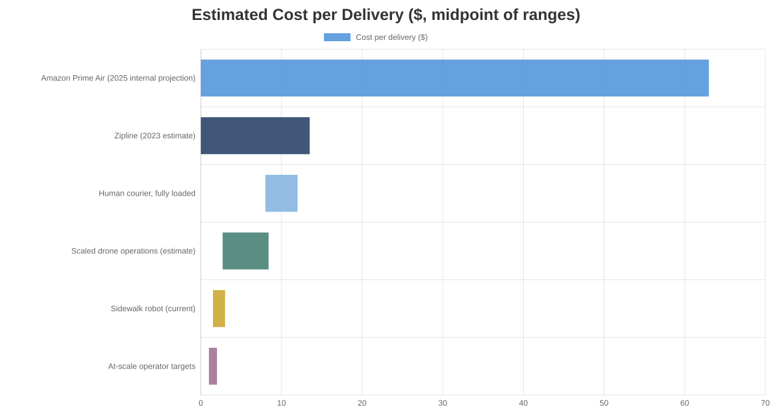
The gap between the $63 and $1.50 rows is not primarily technology — it is utilization. Fixed costs (aircraft, nests, remote operators, compliance) dominate, so cost per delivery falls almost linearly with deliveries per asset per day. This is precisely why Walmart's fulfillment-from-store density is a structural advantage: 4,600+ stores within 10 minutes of 90% of the U.S. population creates the route density that drives utilization, which no standalone operator can replicate.
Consumer willingness to pay bounds the revenue side. McKinsey finds 76% of global consumers open to switching to autonomous delivery and 58% willing to pay a premium — but only 37% of U.S. respondents [217]. Auterion's U.S. survey found 41% unwilling to pay any drone-delivery fee, 41% willing to pay $1–10, and 18% more than $10 [218]; a Portland-area study measured mean willingness to pay at just $2.25 per delivery [222]. The most encouraging datapoint: ~80% of consumers are open to a $3–5 fee when it buys 30-minute delivery [220].
💭 The product is speed, not robots
Consumers pay for "faster and cheaper," not "delivered by a robot." Autonomy is a cost lever and a speed enabler — a viable business model requires cost per delivery below ~$3 at a sub-hour service level, which only route density and high asset utilization deliver.

3. Technology Segments
Failed to fetch picture
Segment Leaders at a Glance (August 2026)
Segment | Leader | Cumulative Scale | Latest Capital Event | Walmart Relevance
Drone operator | Zipline | 2M+ commercial deliveries; 100M+ autonomous miles | $800M at $7.6B valuation (2026) | Incumbent partner since 2021; also partnering with Uber Eats
Drone operator | Wing (Alphabet) | 450K+ deliveries; DFW metro network | Alphabet-funded | Expanding to 270+ Walmart stores by 2027
Drone hardware / UTM | Matternet + ANRA | FAA type-certified M2 aircraft; BVLOS airspace services | Matternet $33M (2026) | Certified-hardware + UTM stack acquirable outright
Sidewalk robots | Starship | 8M+ deliveries; ~2,300 robots live | $50M (2025) | Largest fleet; campus-centric, suburban expansion underway
Sidewalk robots | Serve Robotics | 1M+ deliveries capacity; 2,000-robot Uber deal | $180M (2025); Nvidia-backed | Public (SERV); LA/Miami/Dallas footprint
Middle-mile AV | Gatik | Multi-year Walmart middle-mile ops in AR/TX | $200M incl. strategic (2026) | Deepest existing Walmart autonomy relationship
Last-mile AV | Nuro | Licensing pivot; R3 platform | $203M at $6B valuation (2025) | Prior Kroger/Domino's pilots; licensing model open to retail

3a. Drone Delivery Operators
Zipline leads on cumulative scale — 2M+ commercial deliveries, 100M+ autonomous miles — and private-market value, at a $7.6B valuation after raising ~$800M in 2026 [46, 48, 112]. Wing (Alphabet) has passed 1M deliveries and holds the strongest retail distribution channel via its 270+-store Walmart commitment [10, 12]. Amazon Prime Air lags operationally (~16,000 reported deliveries from 11 locations) but plans expansion toward ~500 locales at a $4.99 price point [53, 54]. Manna (300K+ deliveries; $110M raised) and Flytrex are regional specialists, both integrated with DoorDash — which itself obtained FAA Part 135 certification in July 2026, shifting from aggregator to operator [55, 56, 57, 59].

3b. Drone Hardware & UTM Platforms
Matternet — the only FAA type-certified drone-delivery platform — went public via reverse merger in May 2026, raising ~$33M [62, 63]. A2Z Drone Delivery supplies winches, delivery drones, and automated docking infrastructure to operators [64]. On the airspace layer, ANRA Technologies enabled 55,000+ commercial drone operations per month by June 2026 (users include Amazon Prime Air, DoorDash, Manna, and Matternet) [72], and Airspace Link holds FAA approval as a UTM provider for BVLOS strategic deconfliction [69, 70]. This layer monetizes regulatory infrastructure rather than deliveries — a distinct, capital-light value pool that grows with total flight volume regardless of which operator wins.

3c. Sidewalk Delivery Robots
Starship Technologies has the deepest operating record: 9M+ deliveries across seven countries with ~2,700 robots, funded by a $50M Series C (October 2025; $280M+ total) [73, 74]. Serve Robotics, the public pure-play comparable, reached ~2M cumulative deliveries; Q2 2026 revenue was $3.2M (+404% YoY), but a guidance cut from ~$26M to $9-10M for 2026 — driven by a major partner's volume shortfall — illustrates the segment's utilization and customer-concentration risk [77, 79, 80]. Coco Robotics (500K+ deliveries; $80M raised June 2025, backed by Sam Altman) targets a 10,000-robot fleet [81, 82]. Avride secured up to $375M in strategic commitments from Uber and Nebius and delivers for Uber Eats in four markets [91, 92].

3d. Autonomous Last-Mile Vehicles
Gatik is the most commercially proven — fixed-route, fully driverless middle-mile trucking with Walmart as its first major customer, plus Kroger and Tyson; it raised a $200M Series D in August 2026 led by Qatar Investment Authority and Koch (~$500M cumulative) [99, 100, 128]. Nuro ($6B valuation; $2.3B raised) has pivoted from owned delivery fleets to licensing its autonomy stack, anchored by an Uber/Lucid robotaxi program approaching $500M in Uber commitments [96, 97]. Waymo's delivery activity remains ancillary to robotaxis (Uber Eats/DoorDash in Phoenix) [103, 104]. Also, the Rivian spinout, raised a $200M Series C at a ~$1B valuation with DoorDash as investor and vehicle-development partner [143]. Europe's Clevon was acquired by indiGO Tech in 2025 — an early consolidation marker [107].

4. Recent M&A and Funding Activity
Capital formation has accelerated sharply since early 2025, concentrated in a handful of category leaders; outright M&A remains limited and small, dominated by capability tuck-ins and distressed asset deals — a signal that consolidation is early and strategic acquirers still have room to move before assets reprice.
Capital formation has accelerated sharply in 2026: disclosed equity funding across the tracked companies has more than doubled versus each of the prior two full years, led by Zipline's $800M round [48], Gatik's $200M, and Also's $200M spin-out raise. The 2026 figure excludes undisclosed strategic investments (e.g., Uber's investment in Zipline) and Avride's up-to-$375M in conditional commitments — actual capital committed to the sector is materially higher (methodology in Analyst's Notes).
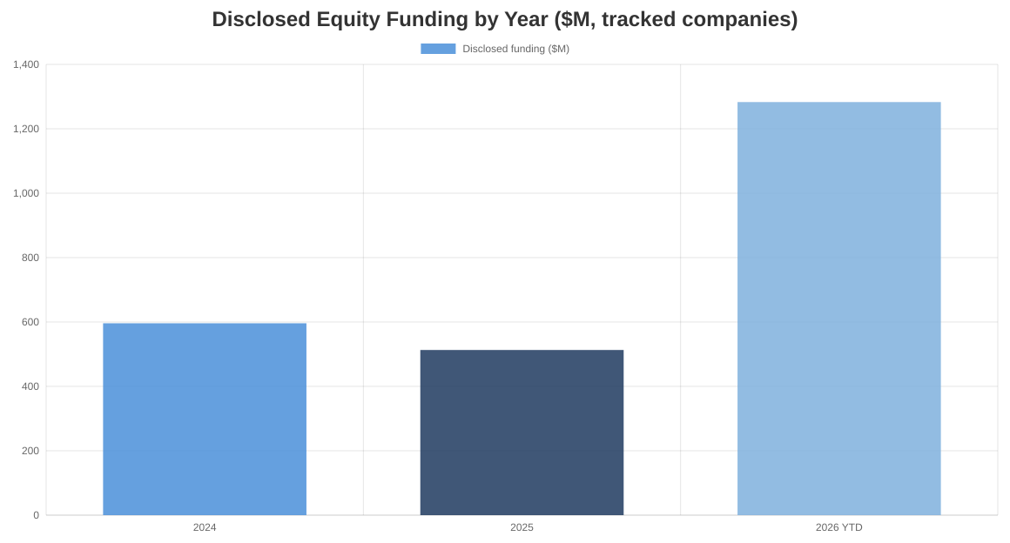
Notable Transactions, 2024 – August 2026
Date | Company / Target | Transaction | Size | Valuation | Notes
Jan–Mar 2026 | Zipline | Series H (two tranches) | ~$800M | $7.6B | Led by Valor Equity Partners [48, 112]
Aug 2026 | Gatik | Series D | $200M | n/d | QIA & Koch Disruptive Technologies; ~$500M cumulative [128]
Aug 2026 | Zipline ← Uber | Strategic investment + Uber Eats partnership | n/d | — | Target of 1M daily drone deliveries by end-2029 [141, 142]
Mar 2026 | RIVR ← Amazon | Acquisition (stair-climbing delivery robots) | n/d | ~$100M last val. | Doorstep-delivery robotics capability [156, 157]
Mar 2026 | Also (Rivian spinout) | Series C, DoorDash participating | $200M | ~$1B | DoorDash board seat; AV delivery vehicles [143]
Jan 2026 | Diligent Robotics ← Serve | Acquisition (hospital delivery robots) | ~$29M stock | — | Healthcare robotics expansion [154]
Apr 2026 | Manna | Series B | $50M | ~$150M est. | ARK Invest-led; U.S. expansion via Tulsa [58, 59]
Oct 2025 | Starship Technologies | Series C | $50M | n/d | Plural-led; fleet target ~12,000 robots by 2027 [73, 76]
Sep 2025 | Flytrex ← Uber | Strategic investment | "tens of $M" | n/d | Uber's first drone-delivery investment [122, 123]
Aug 2025 | Vayu Robotics ← Serve | Acquisition (AI navigation) | ~$39.5M | — | Foundation-model autonomy tuck-in [151, 153]
Apr–Aug 2025 | Nuro | Series E | $203M | $6.0B | Uber and NVIDIA strategic participation [97, 126]
Jun 2025 | Coco Robotics | Series B | $80M | n/d | Sam Altman-backed [82, 117]
Jul 2025 | Clevon ← indiGO Tech | Acquisition (AV delivery robots, Europe) | n/d | — | European consolidation [107]
Jun 2024 | Zipline | Series G | ~$350M | ~$5.0B | Baillie Gifford, Fidelity, Sequoia [109]

Two structural patterns stand out. First, demand platforms are buying optionality through minority stakes, not control: Uber has invested in Zipline, Flytrex, Nuro, and Avride, while DoorDash backed Also and built its own "Dot" robot in-house [105, 141, 143, 145]. Second, the only completed acquisitions have been small capability tuck-ins (Serve's Vayu, Diligent, and teleoperation deals; Amazon–RIVR; Kiwibot–AUTO; Kite Aero's purchase of distressed Swoop Aero assets) [147, 153, 156, 159] — no scaled operator has yet been acquired outright.

5. Key Risks & Watch Items
Risk | Signal to watch | Assessment
Part 108 timing slips | NPRM has sat in OIRA review since July 2026; final rule could slide into 2027+ [43, 45] | High impact — the entire drone-segment repricing thesis is keyed to this rule
Safety incidents & investigations | FAA/NTSB probes into Amazon MK30 incidents incl. a crane collision [183, 184]; NHTSA investigation of Avride covering 16 crash reports [198] | A fatal or high-profile failure would trigger sector-wide regulatory tightening
Community noise & backlash | College Station operations suspended after noise complaints [188, 190]; only 11% of surveyed residents support drones near homes [170] | Site-approval friction slows network buildout even where federal rules permit
Municipal patchwork (ground) | Toronto sidewalk-robot ban; San Francisco and Chicago restrictions [203] | Sidewalk-robot TAM is gated city-by-city, unlike federally preempted airspace
Weather envelope | Most delivery drones limited to ~15–25 kt winds [192]; Amazon halted Phoenix flights in 104°F heat [194] | Structural service-availability ceiling in large parts of the U.S.
Unit-economics execution | Amazon's ~$63/delivery internal projection [168] vs ~$1–2 targets; utilization ramp is unproven at national scale | The cost curve is a forecast, not a fact — density assumptions must hold
Willingness-to-pay ceiling | 41% of U.S. consumers unwilling to pay any drone fee [218]; Meituan's drone volume still ~0.01% of orders after years of operation [210] | Revenue per delivery may cap below cost for longer than investors assume

⚠️ Sector-level contagion risk
The most underpriced risk is correlation: a single fatal or widely publicized safety failure by any operator would tighten regulation and public sentiment for all of them simultaneously. Diligence on any target must therefore assess the sector's weakest operators, not just the target's own safety record.

6. Outlook for Strategic Acquirers
The window for control transactions is narrowing in drones and still open on the ground. Zipline's valuation doubled to $7.6B in under two years and Wing is captive to Alphabet [48], making aerial-operator control transactions expensive or unavailable. Ground segments remain accessible: Starship (~$280M raised) and Coco offer scaled sidewalk fleets at venture-scale valuations [73, 82], and Serve trades publicly with a depressed 2026 outlook following its guidance cut and Uber's full exit from its stake [79, 139].
🎯 Where the Asymmetry Sits for Walmart
Walmart is already the sector's largest demand aggregator — 1M+ drone deliveries and the anchor customer for Wing, Zipline, and Gatik [13, 128]. That demand position converts into acquisition leverage: Walmart can underwrite a target's volume ramp, which no financial buyer can. The highest-asymmetry targets are (a) the enabling hardware/UTM layer (Matternet, ANRA, Airspace Link), where valuations are modest and ownership would confer infrastructure economics across all operators, and (b) ground autonomy with proven Walmart integration (Gatik), where a control position would lock in middle-mile cost advantage before the QIA/Koch capital scales it for competitors [62, 72, 128].

Three considerations should frame corporate-development posture. First, partner-versus-own economics favor owning where utilization is captive. Walmart's store density means a dedicated autonomous fleet (aerial or ground) can achieve the utilization that killed third-party models like DroneUp [24, 28]; assets that are marginal for an independent operator can be accretive inside Walmart's network. Second, Part 108 finalization is the repricing event. A final BVLOS rule — plausibly within 12 months given OIRA review began July 2026 [45] — would de-risk drone operations at scale and likely trigger a step-change in drone-operator and UTM valuations; positions taken before finalization capture that repricing. Third, competitors are assembling multi-modal networks now. Amazon is buying robotics capability (RIVR) and scaling Prime Air toward ~500 locales [54, 156]; Uber and DoorDash are stitching together drone, sidewalk, and AV coverage through investments and partnerships [105, 143]. Walmart's structural advantages — store density, basket economics, and proven delivery demand — are strongest if paired with ownership or exclusivity in at least one modality before the sector's current partnership-based equilibrium hardens into closed networks.

Catalyst Timeline
• | H2 2026  ⚖️ FAA Part 108 final rule  BVLOS NPRM in OIRA review since July 2026 [45]. Finalization is the single largest repricing catalyst for drone-segment assets — position before, not after.
• | END 2026  🚁 Uber Eats × Zipline launch  Consumer drone delivery via Uber Eats begins in initial U.S. markets [141] — the first scaled aggregator-embedded drone offering.
• | 2027  🏪 Wing reaches 270+ Walmart stores  Planned expansion of the Wing–Walmart network across major metros [10], deepening but not exclusively securing Walmart's drone capacity.
• | 2027  🤖 Starship targets 12,000 robots  Roughly a 5x fleet expansion from ~2,300 today [76] — the test of whether sidewalk-robot economics scale beyond campuses.
• | 2029  📈 Uber–Zipline: 1M deliveries/day target  A ~230x scale-up from Zipline's current run rate [141, 163]. Achieving even a fraction would make drone capacity a scarce, contested resource.

Indicative Target Screen
Archetype | Representative targets | Indicative posture | Rationale
UTM / airspace infrastructure | ANRA, Airspace Link, OneSky | Acquisition | Small, strategic, pre-repricing; owning the airspace-services layer benefits every drone partner Walmart uses
Certified drone hardware | Matternet, A2Z Drone Delivery | Acquisition or controlling stake | FAA type certification is a multi-year moat priced at single-digit-hundreds of $M today
Middle-mile autonomy | Gatik | Strategic stake with path to control | Deepest existing Walmart integration; middle-mile economics already work on fixed routes
Sidewalk-robot fleets | Starship, Coco, Serve Robotics | Minority stake / watch | Economics improving but municipally gated; optionality cheaper than control today
Drone operator control | Zipline, Wing | Partner — do not buy | $7.6B+ valuations and Alphabet ownership make control uneconomic; secure capacity contractually instead

Analyst's Notes
Derivation of segment estimates (Section 1 chart). The autonomous ground last-mile figure (~$1.6B, 2025) is derived: $1.963B total autonomous last-mile market × ~82% ground-vehicle share, per Grand View Research's published scope [3]; 2026 extension applies the reported 24.8% CAGR. The drone hardware & UTM estimate (~$0.6B) is analyst-derived as roughly one-third of the $1.94B delivery-drone market, whose published scope explicitly includes hardware, payload systems, docking/charging infrastructure, and integration services alongside operations [1]; no reputable standalone sizing of the hardware/UTM layer was found. Segment figures overlap (sidewalk robots are a subset of ground vehicles) and derive from commercial research publishers whose figures should be treated as directional; McKinsey and Deloitte corroborate direction but publish no standardized market value [5, 6]. Private-company valuations cited throughout are funding-round marks, not audited values.
Derivation of the 2030 ground-segment estimate (§1): Grand View's 2030 total-market projection of $5.93B [3] multiplied by the current ~82% ground-modality share [3] ≈ $4.9B. This assumes the modality mix holds; if drone delivery grows faster (as [179] implies), the ground share — and this figure — would be lower.
Funding-by-year chart methodology (§4): Sums of disclosed equity rounds among tracked companies only. 2024 ≈ $596M (Zipline $350M, Starship $90M, Serve Robotics $126M, Gatik $30M). 2025 ≈ $513M (Nuro $203M, Serve $180M, Coco $80M, Starship $50M). 2026 YTD (through August) ≈ $1,283M (Zipline $800M, Gatik $200M, Also $200M, Manna $50M, Matternet $33M). Excluded: undisclosed strategic investments (e.g., Uber into Zipline), Avride's up-to-$375M conditional commitments, and debt facilities. These are floor figures for capital formation, not totals.
Unit-economics chart caveats (§2): Figures mix vintages and estimation quality — Amazon's ~$63 is a reported internal projection [168]; Zipline's ~$13.50 is a 2023 third-party estimate [162]; scaled-operation ranges [166, 174] are analyst modeling; and the $1–2 row reflects operator-stated targets [164, 175], not achieved costs. Range midpoints are charted. Treat the chart as directional ordering, not a like-for-like comparison.

